School of Economics: Woolsack Drive exit off M3: Go up Cross Campus Road, take the first left onto access road (marked as blue line), head down the hill, bear right and go past the Cricket Oval on your left. When you get to a large open parking lot, you’ll see the School on your right hand side.
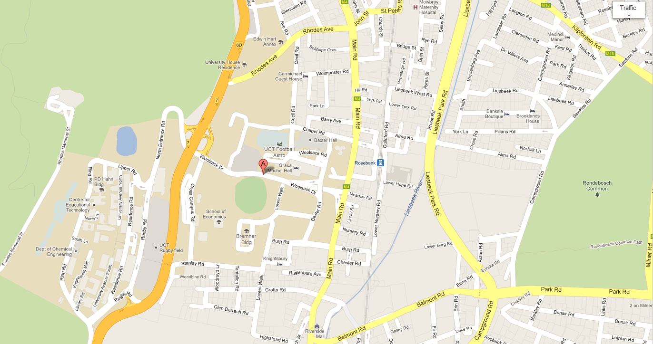
Ref: K3 in the below campus map:

